Young Voices Conversation Information Pack

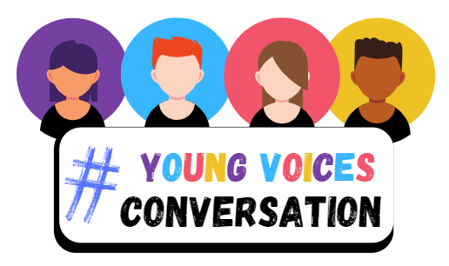

Providing young people with opportunities to give feedback about policing and community safety

Why is it important for the Police and Crime Commissioner and South Wales Police to engage with and seek feedback from young people?
Working on behalf of and in the best interests of young people, is a joint priority for the Police and Crime Commissioner and South Wales Police. Our Children’s Rights Charter and Joint Equality Plan outline our commitment to promoting a culture where young people’s opinions and contributions are recognised, valued and acted upon. Providing young people with opportunities to comment on and challenge the delivery of services that affect them, is key to helping the Commissioner and police to jointly improve on the services provided to children and young people.

What is our Young Voices conversation all about?
Our Young Voices Conversation aims to provide a regular forum for representative groups of young people between the ages of 11 and 25. Young people will be invited to question and comment on policing and safety issues, speaking to police leaders and other organisations about the issues that impact on their everyday lives. Our aim is that by providing an open forum for young people, we can encourage a cross section of individuals to be a part of these important conversations. We would like varied opinions and life experiences to be voiced and taken into account.

Why is it important for young people to be involved in our Young Voices Conversation?
Young people have a right to be listened to and receive information about services and issues that affect their everyday lives. By being involved in our Young Voices Conversation, we hope that young people will feel that they are having the opportunity for their voices to be heard and will feel valued when their feedback is taken into account by the Police and Crime Commissioner and South Wales Police. Through establishing this forum, we want to encourage and empower young people to:
- Have their voice heard and express their views
- Share their ideas and suggestions with us
- Speak directly with the Police and Crime Commissioner and his team, the police and other organisations.
- Share their personal knowledge, awareness and experience of community issues.
- Work with us in developing creative and positive solutions for young people.

How does our Young Voices work?
Our Young Voices Conversation is a tiered approach, offering young people the opportunity to engage with us and take part at local and regional conversations:

Local Young Voices Conversations
Throughout the year, we work with third sector organisations, youth groups and organisations to host regular local conversations with young people in settings they feel comfortable in. Our aim is that by working closely with youth experts and drawing on their expertise, we can encourage young people, who may not ordinarily engage with us, to have the confidence and willingness to take part in this forum.
Topics discussed at local conversations will vary throughout the year based on the issues young people want to discuss with us, as well as topics that South Wales Police and the Police & Crime Commissioner would like to understand a young person’s perspective on.
We summarise the feedback and ideas shared with us by young people from local conversations held across the force area, so that we can collectively review the issues raised and understand the similarities and differences in concerns and opinions of young people across our force area. This helps us to draw conclusions and develop recommendations for positive changes.

Regional Young Voices Forum
Twice a year, we hold a Regional Young Voices Forum, where a small group of young people are offered the opportunity to discuss the findings from their local conversations with our panel members. Our panel members are senior leaders in the police and public sector, who are interested in listening and hearing from young people about the issues important to them and their ideas for positive change.

Feedback
Following on from our Regional Young Voices Forum, young people are invited to attend a 'feedback session ' with the panel members, to find out how the panel intend to take on board the feedback and the ideas shared by young people at local conversations and the regional forum.

Co-Creating
We develop recommendations that aim to address the issues raised by young people and work with and involve young people to progress this work. This helps us to ensure that the content and products we develop are suitable and accessible for young people.

If you are interested in finding out more or would like to get involved, email us at engagement@south-wales.police.uk

